Beat the Algorithm

Leveraging Machine Learning for Hit Songs
Sam Jones, Alejandro Osto, Waldo Barreto Tascón, Joaquín Miño, Yeabsira Seleshi

Executive Summary
This report presents a comprehensive analysis of a dataset consisting of 2,300 songs, incorporating 19 variables that encompass detailed song attributes, popularity metrics, artist information, and musical composition features. The analysis is structured into two overarching sections. The first section provides a detailed explanation of the methodological approach employed for data preprocessing and transformation, including strategies for handling missing values, normalising data, and selecting relevant features. It further explores the segmentation process using the K-means clustering algorithm to identify distinct song groupings and the application of linear regression to examine relationships between song characteristics and popularity metrics.
The second section is specifically addressed to music producers and record labels, translating the findings from the analytical processes into actionable insights. This section provides data-driven recommendations to optimise musical success, guiding strategic decision-making in areas such as artist selection, production techniques, and musical style adaptation. By leveraging the insights derived from this analysis, industry professionals can enhance their understanding of market trends and maximise the potential for commercial success in an increasingly data-driven music industry.

Table of Contents
1 Methodology 2
1.1 Exploratory Data Analysis and Transformation 2
1.2 Segmentation 2
1.2.1 Unsupervised Model Execution 2
1.2.2 Unsupervised Model Evaluation 3
1.3 Linear Regression 3
1.3.1 Supervised Model Execution 3
1.3.2 Supervised Model Evaluation 4
2 Recommendations 4
2.1.1 Focus on popularity drivers within clusters 4
2.1.2 Optimise genre-specific sounds 5
2.1.3 Understand trends in song duration 5
2.1.4 Experiment based on variability 5
2.1.5 Leverage the Impact of artist popularity 5
2.1.6 Stay ahead of current musical trends 5
2.1.7 Balance speechiness in Genre-Specific Contexts 5
Annexes 6

Methodology

Exploratory Data Analysis and Transformation
An analysis of the dataset containing 2,300 songs revealed that only two entries in the loudness column had negative decibel levels. These values were identified as potential errors and were subsequently removed to prevent distortion in the model. Further examination uncovered additional suspiciously low values in the loudness column, leading to the decision to drop the column entirely. Additionally, one row with null values was detected and removed from the dataset. To facilitate potential filtering and grouping during the segmentation process, the values in the duration_ms column were converted to integers.
To categorise the 437 identified sub-genres in the artist_genre column, the most frequently occurring words were analysed to determine the top five genres, and flag variables were created for each. The variability coefficient of all numeric columns was also calculated to assist in feature selection. Among the identified variables, rap and hip-hop were the only pair found to have a significant correlation. This relationship was visualised using a heatmap, which is included in Annex 1. Both variables were retained for use in profiling rather than clustering.

Segmentation

Unsupervised Model Execution
For the selection of the optimal clustering algorithm, an initial exploration was conducted using the hierarchical matching method, along with preliminary experiments utilising DBSCAN. However, after careful evaluation, K-means clustering was ultimately chosen as the preferred methodology due to its effectiveness in achieving the objectives of the analysis.
To determine the optimal value of k, the elbow method was applied. Although a distinct inflection point was not clear from the resulting graph, a k-value of 5 was selected as the most appropriate choice. The corresponding elbow chart is provided in Annex 2.
An algorithm was executed using a superset of the top five variables with the highest variance to identify the optimal combination of three variables for clustering at each value of k. The visualisation for this analysis can be found in Annex 1.
Clustering Variables | Profiling Variables
instrumentalness | liveness | danceability | mode | tempo
speechiness | track_popularity | energy | year | duration_ms
acousticness | artist_popularity | valence | key | genres

The centroids were assigned randomly, and processed repeatedly to achieve a higher silhouette score. The split of the data was very uneven, with cluster 3 containing only 27 songs, and cluster 5 containing more than 50% of all songs, but the silhouette score was 0.492, which indicated a relatively strong clustering, compared to our earliest efforts.
Cluster 1 | Cluster 2 | Cluster 3 | Cluster 4 | Cluster 5
335 | 288 | 27 | 179 | 1277

The clustering solution was visualised on a 3D plot with all 3 of our clustering variables acting as the axes. This visualisation can be seen in Annex 3. We noticed a significant amount of overlap between clusters, alluding to the low silhouette score, however the high spread of data suggested that the selected features contribute meaningfully to the differentiation of data points.
When labelling the clusters we used a heatmap to identify patterns across the 5 clusters from all 19 variables. From this analysis, we assigned the following labels to each cluster:

Cluster 1 | Cluster 2 | Cluster 3 | Cluster 4 | Cluster 5
Dance, hip-hop & rap music | Acoustic, slow, sad pop music | Early 2000s instrumental dance music | Hip-hop/rap, fast and upbeat music | Energetic, non-acoustic, light rock

Unsupervised Model Evaluation
We verified the labelling of the clusters by taking a sample of the first 5 songs in each cluster. The full table of songs sampled from each cluster can be found in Annex 5.
From our sampling, we can see examples of successful profiling in each cluster:
- Cluster 1: Energetic dance-pop with electronic beats and smooth vocals—featuring Enrique Iglesias, Britney Spears, Sting, Melanie C, and Vengaboys.
- Cluster 2: Pop, rock, and R&B with a melancholic, introspective tone—artists include Nine Days, Kandi, Madonna, Filter, and P!nk.
- Cluster 3: Infectious hooks and rhythmic beats, fitting the dance scene—featuring 3 Doors Down, Ricky Martin, Uncle Kracker, and Atomic Kitten.
- Cluster 4: High-energy beats and dynamic flows, blending hip-hop and pop—artists include Melanie C, Afroman, Train, Sum 41, and *NSYNC.
- Cluster 5: The largest and most varied, combining light rock, electric guitar riffs, and uplifting melodies—featuring Mariah Carey, blink-182, U2, Matchbox Twenty, and Alice Deejay.

Linear Regression

Supervised Model Execution
To predict track popularity, we used Linear Regression, a widely used method in predictive modelling. This model assumes that the relationship between the features (predictors) and the target variable (track popularity) is linear, making it a good fit for our data. We applied stepwise regression to select the most relevant features, ensuring that only statistically significant predictors were included.
To assess the relationships between the selected explanatory variables, we computed a correlation matrix. This matrix allowed us to examine potential multicollinearity between variables and ensure that no highly correlated predictors were included in the model. The results of the correlation analysis can be found in Annex 7: Correlation Matrix of Explanatory Variables. This helped us ensure that each variable contributed uniquely to the model without redundancy.

The features selected by the stepwise regression model were:
- artist_popularity : Highly significant, showing popularity of the artist plays a crucial role in the success of a track
- year: The year of the song’s release was also significant, indicating trends and changes in music over time.
- speechiness: The amount of speech in a song has a small yet statistically significant negative effect on popularity.

The model was fitted using Ordinary Least Squares (OLS) – see Annex 8- which estimates the model’s coefficients by minimizing the sum of squared residuals.

Supervised Model Evaluation
R-Squared
The model’s R-squared value was 0.10, meaning it explains just 10% of the variance in track_popularity. This is relatively low, indicating that the model doesn’t fully capture the complexities that influence track popularity.
Mean Squared Error (MSE) and Root Mean Squared Error (RMSE)
The MSE and RMSE for the training dataset are 0.88 and 0.94, respectively, while for the test dataset, they increase to 0.99 and 0.99. These higher values on the test set indicate the model performs better on the training data, but struggles to generalize to new, unseen data. The histograms of predictions (see Annex 9 and 10: Histograms of Predictions - Train & Test Sets) further highlight this discrepancy by showing how the predicted and real values are distributed for both datasets.
Mean Absolute Percentage Error (MAPE)
The MAPE is 6.21% for the training set and 9.43% for the test set. These values suggest that, on average, the model's predictions are off by about 6% for the training set and 9% for the test set, reflecting reasonable but slightly imperfect predictive accuracy.
Residual Analysis
Residuals were checked and showed some pattern, indicating that the model might not have captured all underlying relationships in the data. This points to the need for more complex models to improve fit and prediction accuracy. The residuals plot (see Annex 11: Residual Plot - Real vs. Fitted Values) visually illustrates how well the model’s predictions align with actual values.

Recommendations
Our recommendations to producers are based on a combination of segmentation and linear regression analyses, which help identify the key factors driving a song’s success within specific genres or clusters. The main takeaways from our analysis are the following:

Focus on popularity drivers within clusters
For producers working in a specific genre, it’s crucial to recognise that different musical elements contribute to popularity within each style. If analysis shows that hit songs in a particular genre tend to have high energy and positive emotions (valence), then producers should focus on creating uplifting, energetic tracks. On the other hand, if less successful tracks in the genre tend to have low danceability, adding more groove and rhythmic elements could help boost their appeal.

Optimise genre-specific sounds
Similarly, the analysis shows that in general, songs within clusters follow certain patterns, which should be seen as a recipe for success. For example, Pop (genre_pop) tracks should emphasise danceability, energy, and valence to maximise mainstream appeal. On the other hand, Hip-hop/Rap (genre_rap, genre_hip_hop) should prioritise speechiness and tempo to align with spoken word-heavy content. Rock (genre_rock) benefits from higher instrumentalness and energy.

Understand trends in song duration
In Cluster 3, where dance music is most prevalent, songs have a longer duration. This suggests that song length varies by genre, and producers should be mindful of what works best for their audience. While dance tracks often benefit from extended playtime for buildups and drops, today’s shift toward short-form content means attention spans are shorter. Producers should strike a balance between maintaining the energy of their genre and keeping listeners engaged.

Experiment based on variability
A high standard deviation in a feature means there is significant variation in track styles within a cluster, offering producers room for experimentation. For example, if a genre has a wide range of tempos, testing both slower and faster tracks can help find the right balance. Similarly, if speechiness varies, incorporating both spoken and sung elements may create a more engaging sound. By recognising these variations, producers can explore different creative approaches while still aligning with what works in their genre.

Leverage the Impact of artist popularity
The model indicates that there is a strong positive relationship between artist popularity and track popularity. Producers should focus on collaborating with popular or rising artists, as their established fanbase directly improves the track's reach and engagement. For tracks featuring emerging artists, partnering with well-established names can greatly increase visibility.

Stay ahead of current musical trends
The model indicates that songs released in recent years tend to perform better. In order to maximize a track's potential, producers should focus on current trends and create music that connects with today's audience. Adapting to the changing musical landscape—whether through instrumentation, design or song theme—can lead to greater success with current listeners.

Balance speechiness in Genre-Specific Contexts
While speechiness tends to negatively impact track popularity, it remains an important aspect in hip-hop and similar genres where spoken elements are essential. Producers in these genres should use speech elements thoughtfully, ensuring they enhance the music rather than overthrow it. Striking this balance can lead to a more engaging experience without compromising the overall appeal of the track.

Annexes
Annex 1. Silhouette scores for different combinations
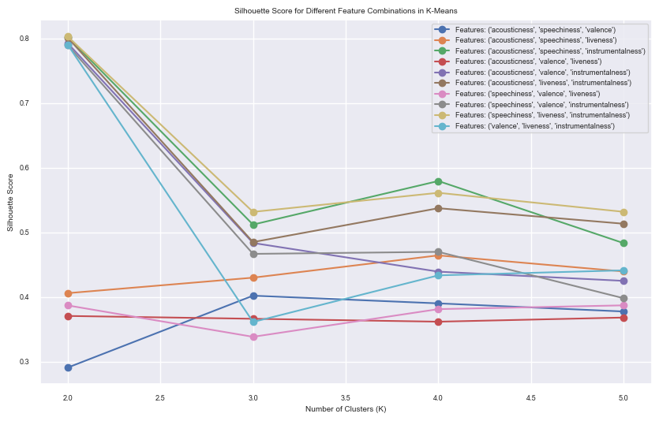
Annex 2. Variable Correlation Heatmap
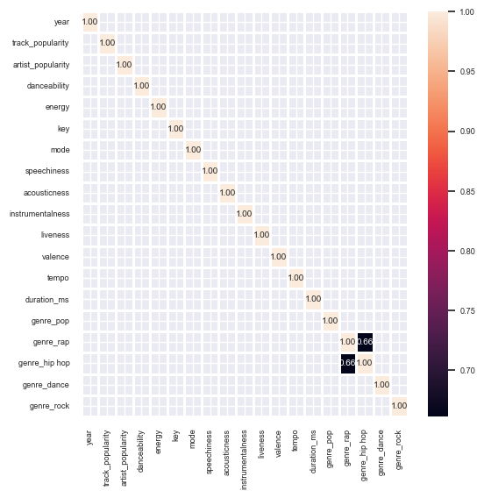

Annex 3. Elbow Chart
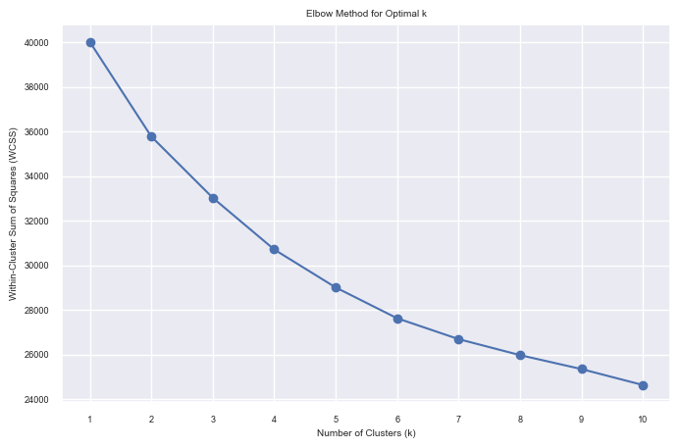
Annex 4. Clustering Visualisation (before and after updating centroids)
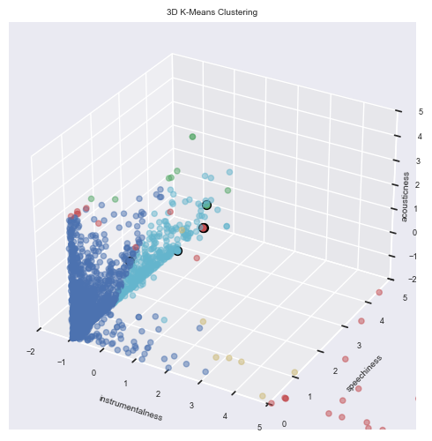
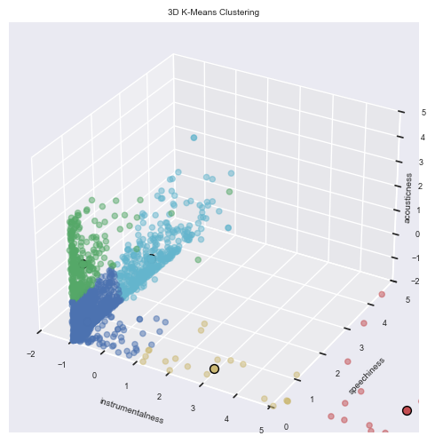

Annex 5. Cluster Profiling Heatmap
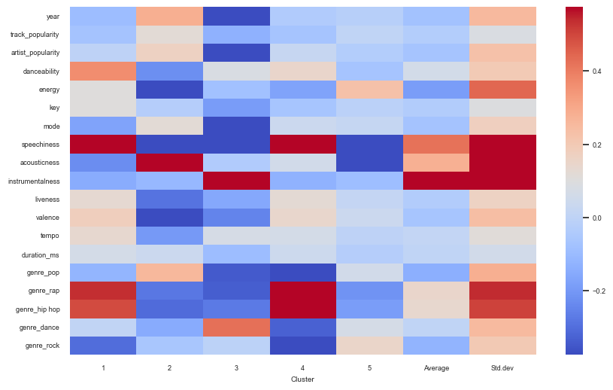
Annex 6. Songs Sampled from final clustered data
index | track_name | artist_name | Cluster
8 | Be With You | Enrique Iglesias | 1
13 | Born to Make You Happy | Britney Spears | 1
24 | Desert Rose | Sting | 1
61 | Never Be The Same Again | Melanie C | 1
74 | Shalala Lala | Vengaboys | 1
1 | Absolutely (Story of a Girl) - Radio Mix | Nine Days | 2
27 | Don't Think I'm Not | Kandi | 2
59 | Music | Madonna | 2
78 | Take A Picture | Filter | 2
87 | There You Go | P!nk | 2
7 | Be Like That | 3 Doors Down | 3
76 | She Bangs - English Version | Ricky Martin | 3
120 | Follow Me | Uncle Kracker | 3
196 | Whole Again | Atomic Kitten | 3
286 | The Tide Is High - Radio Mix | Atomic Kitten | 3
43 | I Turn To You | Melanie C | 4
105 | Because I Got High | Afroman | 4
114 | Drops of Jupiter (Tell Me) | Train | 4
118 | Fat Lip | Sum 41 | 4
122 | Gone | *NSYNC | 4
2 | Against All Odds (Take A Look at Me Now) - Mariah Only | Mariah Carey | 5
3 | All The Small Things | blink-182 | 5
9 | Beautiful Day | U2 | 5
10 | Bent | Matchbox Twenty | 5
11 | Better Off Alone | Alice Deejay | 5

Annex 7. Correlation Matrix of Explanatory Variables

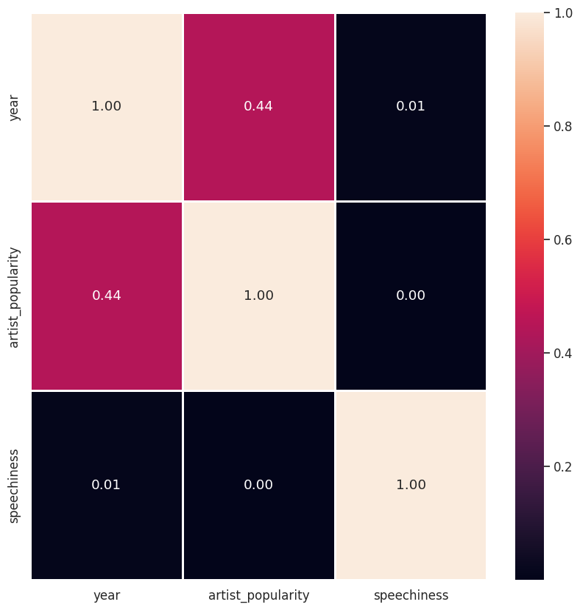

Annex 8. OLS Regression Results
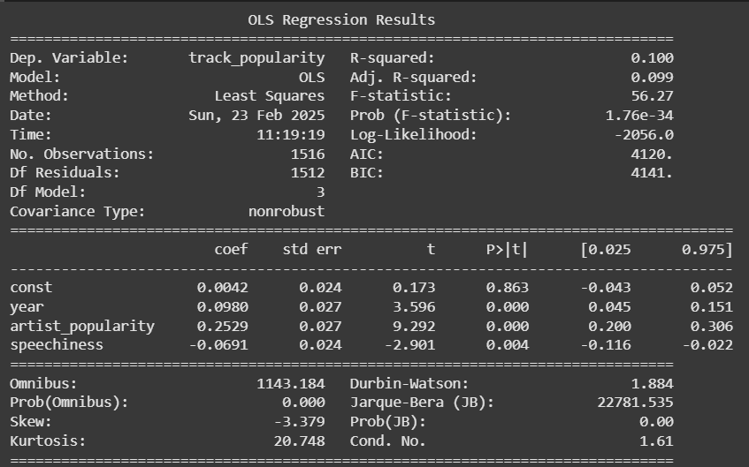

Annex 9. Histogram of dependent – train dataset

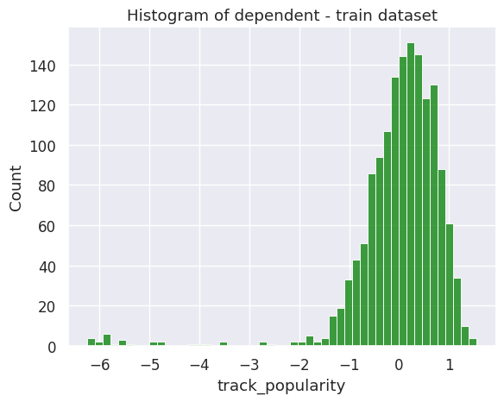

Annex 10. Histogram of dependent – test dataset

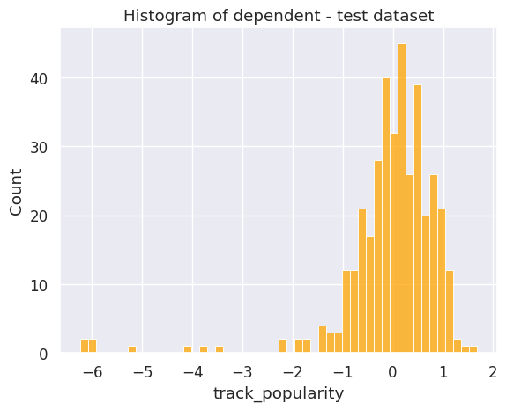

Annex 11. Residual Plot – Real vs. Fitted Values

